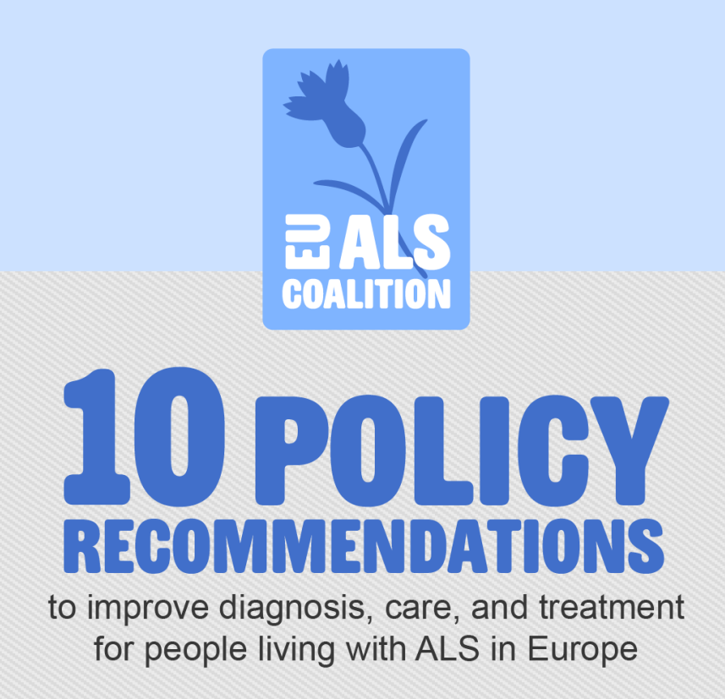

EUpALS is partner of the #EUALSCoalition.

On September 7 2023, 10 policy recommendations to improve ALS diagnosis, care and treatment were unveiled at an event in the European Parliament Brussels. EUpALS Chairwoman Evy Reviers participated in the panel discussion.

We are proud to have contributed to and supported the coalition in this important endeavor, and we are eager to see how these recommendations will come to life.

Learn all about the EU ALS Coalition on www.alscoalition.eu and download the policy paper.

